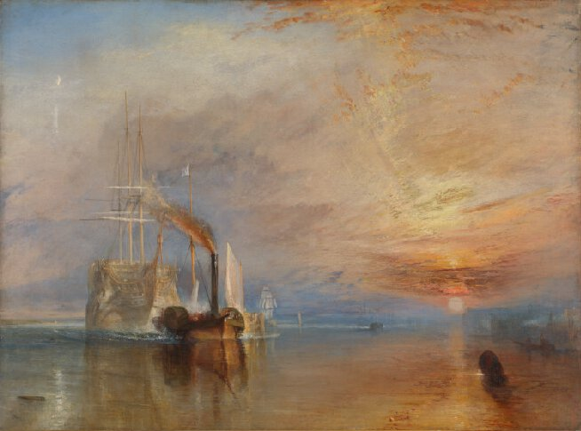
The Fighting Temeraire
The 98-gun ship 'Temeraire' played a distinguished role in Nelson's victory at the Battle of Trafalgar in 1805, after which she was known as the 'Fighting Temeraire'. The ship remained in service until 1838 when she was decommissioned and towed from Sheerness to Rotherhithe to be broken up.
The painting was thought to represent the decline of Britain's naval power. The 'Temeraire' is shown travelling east, away from the sunset, even though Rotherhithe is west of Sheerness, but Turner's main concern was to evoke a sense of loss, rather than to give an exact recording of the event. The spectacularly colourful setting of the sun draws a parallel with the passing of the old warship. By contrast the new steam-powered tug is smaller and more prosaic.
Turner was in his sixties when he painted 'The Fighting Temeraire'. It shows his mastery of painting techniques to suggest sea and sky. Paint laid on thickly is used to render the sun's rays striking the clouds. By contrast, the ship's rigging is meticulously painted.

